Dominic Assia Section 007L 1:25 – 3:20pm

In this lab you will learn:

1. *How to wire a circuit on your breadboard*
2. *How to build and test a simple circuit*
3. *How to use a digital oscilloscope*

Working in the Online Laboratory - Parts and Equipment

# Using your breadboard

An illustration of a breadboard is shown in Figure 1. A breadboard is just an array or matrix of holes housing tiny electrical contacts. The contacts are designed to accept the pins of DIP ICs, other electronic parts, and connecting wires. ICs and other devices are plugged into the breadboard straddling the center trough (the center shaded area in Figure 1). Note that holes in area A are electrically isolated from the holes in B. Also, each of the five holes in any vertical column (area A or B) are tied together internally but isolated from all other columns. VCC and GND connections are made from your power supply to your breadboard via terminals provided for that purpose. Then using connecting wire, you must route VCC to one of the four VCC/GND buses illustrated in Figure 1. A similar connection is required for GND, using a different bus, of course. Each bus consists of a single row of holes all tied together internally.

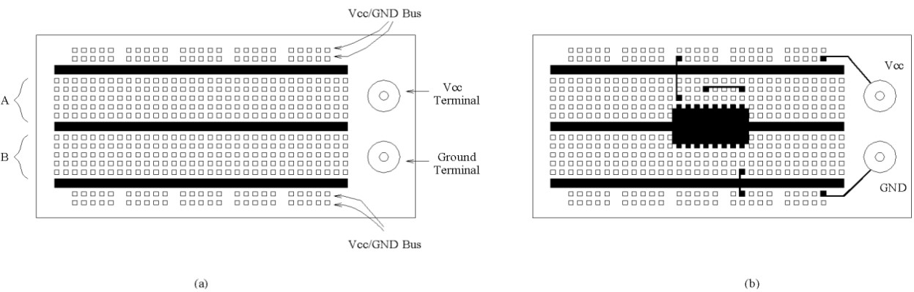

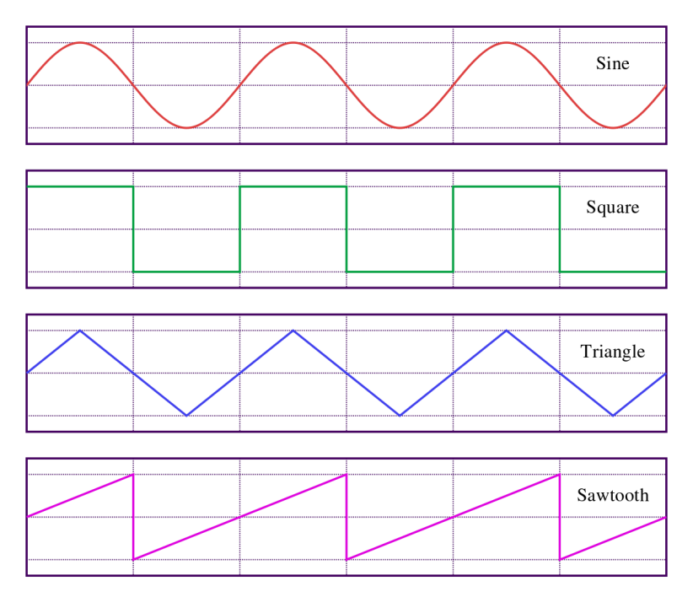

*Figure 5: Different types of waveforms*

# Using an oscilloscope

An oscilloscope is an electronic test instrument that allows you to view periodic signals. The signal is viewed as a 2-dimensional image with x-axis representing time and the y-axis representing voltage. There are various controls on the oscilloscope panel to allow you to adjust various settings including scope intensity (brightness of the display), the voltage scale, the timescale (frequency), and the trigger source and characteristics. The trigger is the specific condition that must occur for the scope to start tracing or displaying a waveform. For example, a trigger could be observation of a rising voltage that reaches 1.2V. When the trigger signal is observed the signal is displayed on the scope, drawing from left to right using the time base prescribed by the user (x-axis setting). When the signal trace reaches the right side of the display, the scope waits for the trigger signal and then repeats the display process, starting again at the left side of the display. Many scopes allow you to view 2 different signals (called a 2-channel oscilloscope). Oscilloscopes display the shape of any analog (or digital) signal up to the bandwidth limit of the scope.

Activities

# Using the Breadboard for Lighting an LED

Make sure to watch the tutorial videos on how to use BreadboardSim, and once you have done that then you are able to start the activities.

1. Connect the wires appropriately.
2. Set up the LED of your choosing.
3. Run the simulation
4. Screenshot circuit and results.
   * What would happen if you just connected a powered wire to an LED? Would it light up?

*No, connecting just a single powered wire to an LED will not allow it to light up. You must have a positive (VCC) and negative (GND) powered wires connected in the correct direction to allow the LED to light up.*

* + What would happen if you put 2 powered wires to an LED (one on each of the probes of the LED)? If we were in person what do you think would happen to the LED?

*This depends on the difference in voltage. If there was a large enough difference in voltage*

*If we were conducting an in-person experiment, the LED would pop/sizzle because of its directional bias. This would destroy the diode in the LED, and it would no longer function. In this case the change in voltage is zero and the LED will not light up, but it won’t break.*

An LED is like a typical diode in that when it is reverse biased, it has a very high resistance and looks like an open circuit as shown in Figure 2.1a. When the diode is forward biased, current flows through the diode and there is a drop of 0.7V across the diode as shown in Figure 2.1b. An LED is different from a typical diode in that when it is forward biased it emits light, and the voltage drop across an LED is typically higher (on the order of 1.6V) than the drop across a diode.

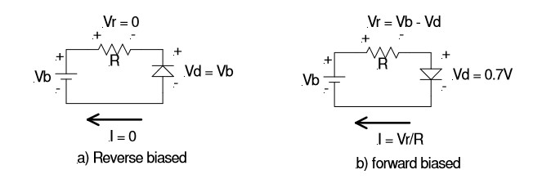

*Figure 6 Diode operation. a) Reverse biased, I = 0 and Vd = Vb. b) Forward biased, I = Vr/R and Vd = 0.7V*

The above analysis can be made using Ohm’s Law and Kirchhoff’s Voltage Law. A common LED has a forward biased voltage drop of about 1.6V and will operate at a reasonable brightness if the current through the LED is about 10mA. To drive an LED with a CMOS gate output we need to verify that the gate has sufficient current to drive the LED.

# Observing the waveforms generated by using a oscilloscope

Continue to use the same LED circuit you had from before in Activity 1. Set up an oscilloscope probe in your circuit to observe the results of when the LED is lit.

1. Place oscilloscope probe.
2. Capture screenshot of the results.

• What voltage is showing on your oscilloscope graph? Why is this? How could you change this value?

*The oscilloscope shows a 5v voltage, because the VCC rails on the side have a voltage of 5v. We can alter this value with resistors and/or change the VCC rail voltage.*

# Additional Questions and Instructions

When submitting this lab make sure to attach all screenshots that you were asked to take. Also make sure to answer any questions that were asked during the activities and provide those answers in your submission, including answers to the questions below! Put all these things inside of a doc or pdf.

1. Why do we ground our circuits?

*We ground the circuits so that the electrons have somewhere to flow out of the system. Ground also acts as a ‘zero’ reference point for voltages in the circuit.*